Task 1: AI Lifecycle of the Problem Statement
Problem Statement
A Curriculum–Industry Skill Alignment Decision Framework to Identify Employability Skill Gaps Among CSE Graduates
The AI lifecycle defines the sequence of stages involved in developing and maintaining the proposed machine learning system, from problem definition and data collection to model evaluation, interpretation, and monitoring. Each stage is mapped specifically to the Curriculum–Industry Skill Alignment problem to demonstrate how the AI approach will be applied, rather than listing the lifecycle in generic terms.

The Lifecycle at a Glance
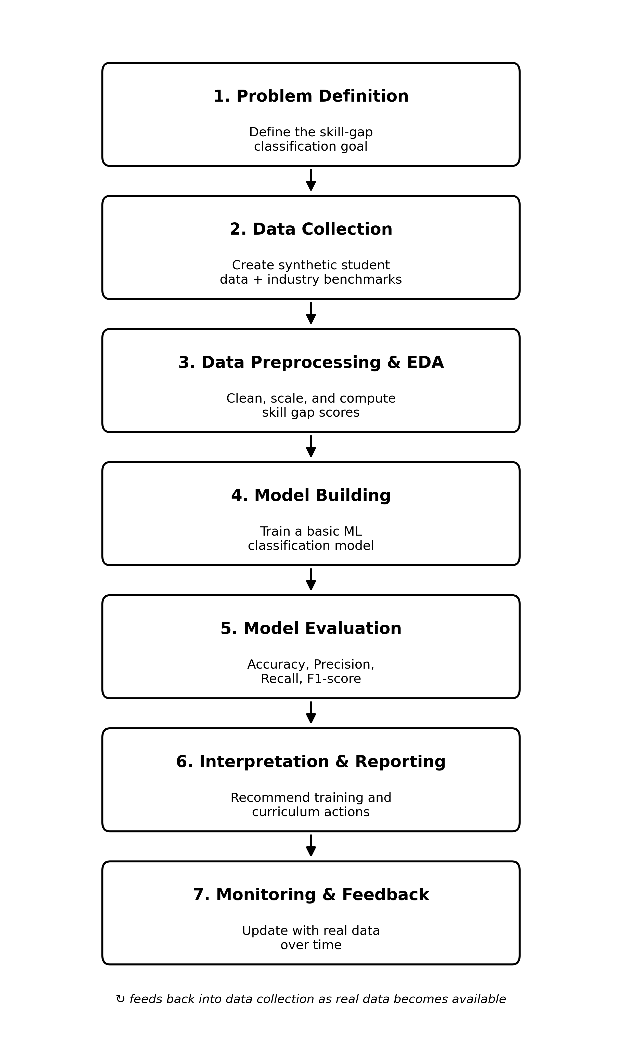

Stage-by-Stage Explanation
1. Problem Definition
This is where I define exactly what the project is trying to do: classify CSE graduate students into Low, Medium, or High skill-gap categories, based on how their skill levels compare against what the industry expects. The target variable here is the skill-gap category, and the inputs are skill scores across areas like programming, databases, problem solving, communication, cloud computing, teamwork, and aptitude — this matches the scope I already defined in my project proposal. I'm also setting the success criteria at this stage: the model should be able to classify a student into the right gap category reasonably accurately when tested on data it hasn't seen before.
2. Data Collection
Since I don't have access to real student records or verified industry hiring data, I'm building a synthetic dataset for this first version of the project. I'll generate skill scores (0–100) for a set of hypothetical students across all the skill categories, and separately define fixed industry benchmark scores for each skill — these represent what the industry is assumed to expect. I already flagged in my risk analysis that synthetic data won't perfectly reflect real students, which is exactly why this stage matters — it's the foundation everything else is built on, so I want to be upfront about its limitation rather than pretend it's real data.
3. Data Preprocessing and Exploratory Data Analysis
Once the dataset exists, it needs to be cleaned and prepared before any model can use it. This includes scaling the skill scores so they're on a comparable range, and calculating the actual 'gap' for each skill by subtracting the student's score from the industry benchmark. I then combine these individual gaps into one overall gap score per student, which gets bucketed into the three categories (Low/Medium/High) that become my classification labels. Alongside this, I'll do some exploratory analysis — looking at how scores are distributed for each skill, whether any skills are correlated with each other, and whether the three gap categories end up reasonably balanced or heavily skewed toward one class.
4. Model Building
For this stage I'm keeping things simple, as per my proposed methodology — using one basic classification model rather than jumping into anything complex. A Decision Tree classifier will be used as the basic classification model, since it's easy to interpret and explain, which matters for a project like this where the whole point is to understand why a student falls into a particular gap category, not just get a black-box prediction. A Decision Tree also makes it easy to show the actual decision path (for example, whether a student's cloud computing gap exceeds a threshold), which is useful when explaining the results. I'll split the dataset 80/20 into training and testing sets, train the model on skill scores (or the computed gaps) as inputs, and the gap category as the output.
5. Model Evaluation
After training, I need to check whether the model is actually doing its job well. I'll use standard classification metrics — accuracy, precision, recall, and F1-score — and look at a confusion matrix to see specifically where the model gets confused (for example, if it's mixing up Medium and High gap students). This tells me whether the model is reliable enough to trust for the next stage, or whether it needs adjustment.
6. Interpretation and Reporting
This is where the project actually becomes useful rather than just being a technical exercise. I'll look at which skills are contributing most to the gaps identified by the model — feature importance essentially tells me which skill areas are pulling students down the most. From there I can translate that into actual recommendations, like suggesting extra training in cloud computing if that consistently comes up as the biggest gap area. This stage connects the technical output back to the original motivation of the project: helping departments and students figure out where to focus.
7. Monitoring and Feedback
Since industry-required skills don't stay the same for long, a model trained once on synthetic data would go stale fairly quickly if this were ever used in practice. I'm including this stage to show that I understand this isn't just a one-time exercise — in a more developed version of this project, the pipeline would be re-run whenever real student data becomes available, or whenever the industry benchmark scores are updated to reflect what's currently in demand. For now, this stays as a planned extension rather than something I've implemented, but I think it's important to include because it's what separates a proper ML lifecycle from a single one-off script — and it ties back to the MLOps angle of the project.

